2a) Explore various Flutter widgets (Text, Image, Container, etc.)

Code for Implementing Flutter Widgets Text:

import 'package:flutter/material.dart';

void main() {
runApp(MyApp());
}

class MyApp extends StatelessWidget {
@override
Widget build(BuildContext context) {
return MaterialApp(
title: 'Text Widget Demo',
home: Scaffold(
appBar: AppBar(
title: Text('Text Widget Example'),
),
body: Center(
child: Text(
'Hello, Flutter!',
style: TextStyle(
fontSize: 24, // Text size
fontWeight: FontWeight.bold, // Bold text
color: Colors.blue, // Text color
letterSpacing: 1.5, // Space between letters
),
textAlign: TextAlign.center, // Align text center
),//Text
),//center
), //scaffold
); //MaterialApp
}
}

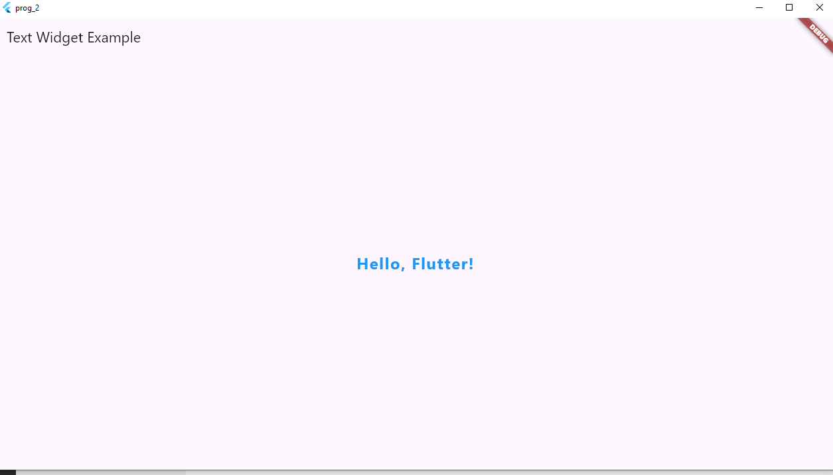

Code for Implementing Flutter Widgets Image:
import 'package:flutter/material.dart';
void main() {
runApp(const MyDesktopApp());
}

class MyDesktopApp extends StatelessWidget {
const MyDesktopApp({super.key});

@override
Widget build(BuildContext context) {
return MaterialApp(
home: Scaffold(
appBar: AppBar(
title: const Text("Image from Internet"),
),
body: Center(
child: Image.network(
'https://flutter.github.io/assets-for-api-docs/assets/widgets/owl.jpg',
width: 300,
height: 300,
fit: BoxFit.cover,
),
),
),
);
}
}
Output
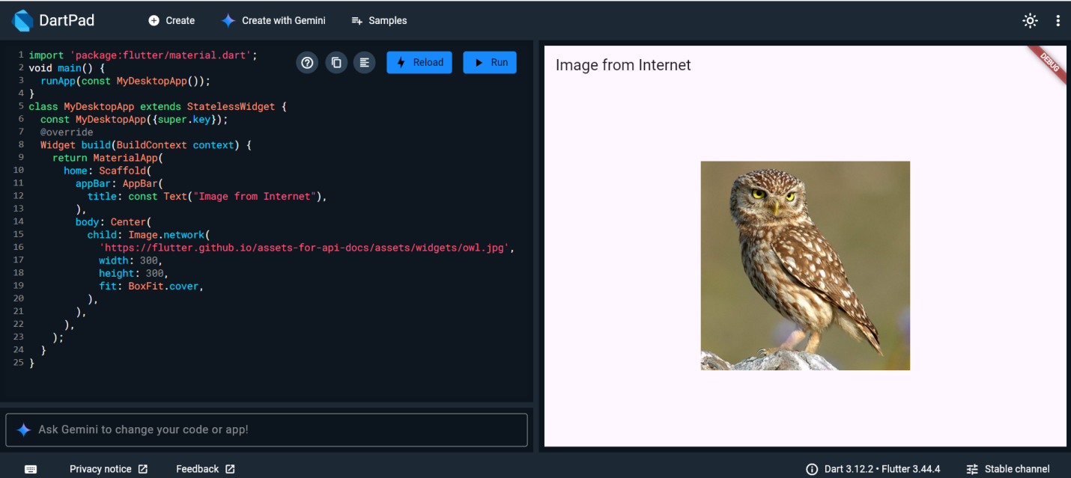
Code for Implementing Flutter Widgets Container:

import 'package:flutter/material.dart';

void main() {
runApp(MyWindowsApp());
}

class MyWindowsApp extends StatelessWidget {
@override
Widget build(BuildContext context) {
return MaterialApp(
title: 'Flutter Windows App - Container Demo',
home: Scaffold(
appBar: AppBar(
title: Text('Container Widget Example'),
),
body: Center(
child: Container(
width: 300,
height: 150,
padding: EdgeInsets.all(20),
margin: EdgeInsets.all(20),
decoration: BoxDecoration(
color: Colors.lightBlueAccent,
borderRadius: BorderRadius.circular(15),
border: Border.all(
color: Colors.blue,
width: 3,
),
boxShadow: [
BoxShadow(
color: Colors.black26,
blurRadius: 10,
offset: Offset(4, 4),
),
],
),
child: Center(
child: Text(
'This is a Container!',
style: TextStyle(
fontSize: 20,
color: Colors.white,
),//Text style
),//Text
),//center
),//container
),//center
),//scaffold
);//MaterialApp
}
}

Output:

